OPEN HORNET BUILD NOTES

Paint Colors:
- Undercoat: Cromellin Aquablock white, 4L tin
- Yellow: Pantone 7408C (Test pot so Low sheen only)
- Dark Gull Grey: RAL 7037 (Low Sheen) 4L tin, You'll need 10L tin if you want to spray the entire pit
- Black: Color match off Rowmark but up to your own choice. (Taubmans Ultimate enamel, Semi Gloss) 1L if roller, 4L if spraying.
- White: An untinted pot of Dulux white base. (Dulux Wash and wear interior Semi Gloss) (1L)
Load up on 2 rolls of 400 grit sandpaper

Buttons

Tamiya Haze Grey TS-32

Validating PCB Layout
3d view first
then plot – go to drill gsettings and save as SVG and generate MAP file
Open SVG in Adobe illustrator
Export as DXF (setting verion to 2006 scale 1mm = 1 unit
import into viso as cad object

Resin Printer Settings

Trying a fast run with White
3 layers @ 45
3 second sper layer as detal was lost of comm knob

2 seconds too short – and 3 seconds may be a little low
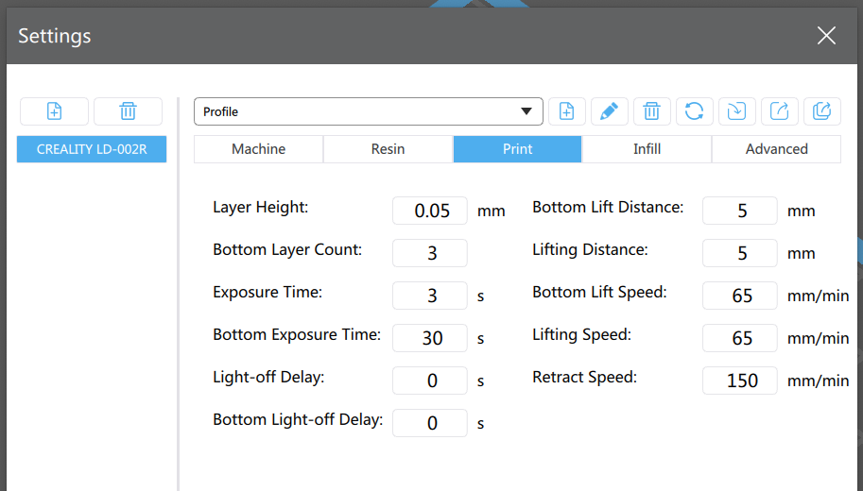

For Clear Resin

45 Bottom
5 per layer

For Black

45 Bottom
9 Seconds per layer

Ran test print for holes using clear resin

10mm square goes to 10.8
2.5mm circle ends @ 2.4
2mm circle ends at 1.8
6.3mm circle ends at 6.1

So take away add at least 0.2mm buffer for holes

Calibrating Prints for the Resin Printer

Using Chutibox ss slicer.

For the AMPCD buttons
The top according to drawings should by 10.33mm Heigh 6.12
Prusa produces a 10.26-10.3 6.03
Creality using defaults produces 10.68 10.73 Heigh 5.5 5.62

H | X | Y
6.12 | 10.33 | 10.33 | Drawing | 6.01 | 10.16 | 15.67
5.5 | 10.78 | 10.8 |  | 5.68 | 10.41 | 15.8
5.5 | 10.68 | 10.65 |  | 5.79 | 10.5 | 15.88
5.79 | 10.55 | 10.57 |  | 5.58 | 10.44 | 15.88
5.48 | 10.77 | 10.85 |  | 5.83 | 10.4 | 15.85
5.8 | 10.58 | 10.53 |  | 5.79 | 10.47 | 15.86
5.6 | 10.6 | 10.62 |  | 5.72 | 10.44 | 15.8
5.67 | 10.56 | 10.6 |  |  | 10.47 | 15.84
5.55 | 10.55 | 10.63
5.61 | 10.58 | 10.53 |  | 5.73166666666667 | 10.4471428571429 | 15.8442857142857
5.55 | 10.58 | 10.61
5.55 | 10.66 | 10.62 | Multiplier | 1.04856062808956 | 0.972514699849583 | 0.989000090163195
5.66 | 10.8 | 10.75
5.77 | 10.6 | 10.64
5.6 | 10.68 | 10.65
 | 10.51 | 10.56
5.61642857142857 | 10.632 | 10.6406666666667
1.08966043494849 | 0.971595184349135 | 0.970803834346219 | Multiplier
So for longer measurements the measure becomes more accurate
White Resin threads ok if there is plenty of clearance around the hole drill 2.5 for 3mm tap

Knobs

MS21385-04ENN
MS21385-04BNN
MS21385-04CNN
MS21384-04ANN
MS21384-04DNN
MS21384-04DBN
MS21385-04CNN
MS21387-18BN
Korry BP246-A1B1
Kory RD239-A1G2
OBOGS Knob-1

UFC 2.2 Inch OLEd need to join pins

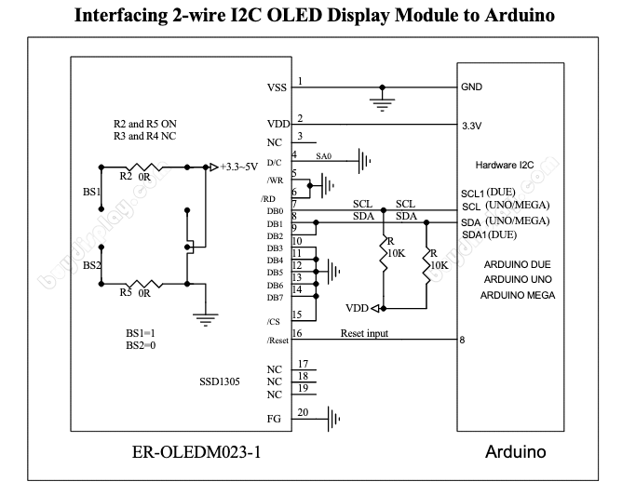
https://www.buydisplay.com/arduino/Interfacing_ER-OLEDM023-1_to_Arduino.pdf

L. Walker08/06/2020
Ah yes, spoke with DG yesterday, he is doing the good ol' green LED floodlighting and call it a day.
I am still doing the same, bought this stack of led "Number plate Lights" off ebay, chuck some green theatre gel over the front and they work a treat.
https://www.ebay.com.au/itm/4pcs-LED-License-Number-Plate-Light-Screw-Bolt-Bulbs-5050-SMD-For-Car-Motorcycle/124189890854?ssPageName=STRK%3AMEBIDX%3AIT&_trksid=p2060353.m2749.l2649
eBay
4pcs LED License Number Plate Light Screw Bolt Bulbs 5050 SMD For C...
2IN 1 Car motorcycle LED card light -- 2. Durable, Easy to Install, Super bright LED, Long lasting & Low consumption. We will be happy to help. Light Color: White. Wire Length: approx 27cm. Thread Length: approx 16mm.

Thanks for hte point on the connect Ben - I found the link to the smaller OLED https://www.ebay.com/itm/192332990775
eBay
0.66 inch White 64x48 OLED Display Module SPI I2C 3.3-5V for Arduin...
1 0.66in OLED Display Module 64x48 Screen SPI I2C 3.3-5V for Arduino AVR STM32. Interface :SPI&I2C. hope you could understand. Light Color:white/blue. DC:data/command wire. RES:reset wire.

correct like these ones - I just need to find out where my white ones went- https://www.ebay.com/itm/0-91-Inch-128x32-IIC-I2c-White-Blue-OLED-LCD-Display-Module-3-3-5v-For-Arduino/392552169768?ssPageName=STRK%3AMEBIDX%3AIT&var=661536491479&_trksid=p2057872.m2749.l2649
eBay
0.91 Inch 128x32 IIC I2c White / Blue OLED LCD Display Module 3.3/5...
IIC interface. OLED display, no need backlight, self-illumination, the display performance is better than the traditional LCD display, also lower consumption. VCC: Power + (DC 3.3 ~5v). Display Color:White/Blue.

https://www.ebay.com/itm/302381365335
eBay
White OLED Module Display 128x32 SPI I2C 2.2 inch Arduino,Raspberry...
Because the display makes its own light, no backlight is required. 2.2" 128x32 Pixels OLED Display with Breakout Board Datasheet. Of course, we wouldn't just leave you with a datasheet and a "good luck!".

L. Walker09/02/2020
https://pagnianimports.com.au/products/buttkicker-advance-transducer
Pagnian Advanced Simulation
ButtKicker Advance Transducer
Buttkicker Advance Transducer, Free Shipping Australia Wide with Interest Free Finance Available
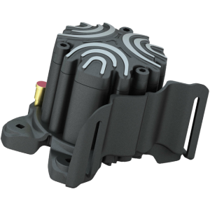

https://www.itead.cc/nextion-nx8048k070.html This is the model is have.
Nextion Enhanced NX8048K070 - Generic 7.0'' HMI Touch Display
The Nextion Enhanced versions support built-in RTC, support save data to Flash, support GPIO, larger flash capacity and larger CPU clock. The enhanced Nextion series has 7 size covers from generic 2.4'' to 7.0''.

https://www.ebay.com.au/itm/450Pcs-Female-Thread-Knurled-Nuts-M2-M3-M4-Brass-Threaded-Insert-Round/274331758966?ssPageName=STRK%3AMEBIDX%3AIT&_trksid=p2057872.m2749.l2649
eBay
450Pcs Female Thread Knurled Nuts M2 M3 M4 Brass Threaded Insert Round
1 set of 450pcs M2-M4 Nut Set. Are you looking for a professional, yet affordable Brass Knurled Nut?. Are you in search of a sturdy, trustworthy tool that can do multiple jobs at once?. If yes, look no further!
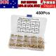

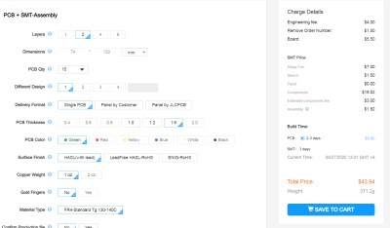
For Fuel Panel W/LED SMT
That is US$ and add shipping + $5 for the molex connectors + Cap

L. Walker09/28/2020
Long story short, WS2812B LED's only come in SMD 3535 or 5050 packages. Would love to go through hole too but just can't happen.

bnepethomas09/28/2020
Are those multicolour?

Ben-11109/28/2020
Yep

L. Walker09/28/2020
Yes, RGB and addressable
They throw out a stack of light too
Worldsemi-WS2812B-B_C114586.pdf
620.14 KB
Control circuit is built into the LED

bnepethomas10/11/2020
goo site to know about - https://cloudconvert.com/dwg-to-dxf
DWG to DXF | CloudConvert
>DWG to DXF Converter - CloudConvert is a free & fast online file conversion service.

Gents. I have asked 100 times. But the discord is a pain for looking up past messages. Need x3 of these (and 1 spare) for the DDI and AMPCD https://www.ebay.com.au/itm/New-10-1-LCD-Display-Screen-Monitor-HDMI-VGA-2AV-Driver-Board-for-Raspberry-Pi/321432203659?ssPageName=STRK%3AMEBIDX%3AIT&_trksid=p2057872.m2749.l2649
eBay
New 10.1' LCD Display Screen Monitor HDMI+VGA+2AV Driver Board for ...
HDMI Input: HDMI 1.1 version. Signal Input: 2 AV + VGA. VGA input: 1024 600 physical resolution ,support for resolutions range 640×480 - 1600×1200 adjusted between ! 1 x HDMI+VGA+2AV Driver Board. B, boot, reversing signal, switch to AV2, reversing the signal disappears ,bac...
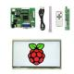
Thanks. And sorry for asking again.  I promise I will order today.

what was the library of choice for playing with the backlighting leds? SpeedLed?

L. WalkerYesterday at 2:53 PM
Fast LED

FastLED-master.zip
348.24 KB
Just throw in WS2812B as the chip model definition.

Legend Plate (1.6mm Rowmark) Lightplate (4.5mm Opaque Acrylic) Backplate (3mm Black Acrylic) Backlighting (1.6mm PCB)

Integrating a Winwing Throttle

Some surgery is needed to install a Winwing Throttle. Originally I had planned to modify a piece at a time, attempting to align as things went along. But then realised that I can design the whole thing in Fusion 360, and that way everything aligns.

So heres the journey.

I’m using Fusion 60 as it is free for Personal Users. There are a few capabilities that locked out, but there still is enough to make it usable. The subscription last 12 months, and then after 12 months you need to renew the subscription, which basically involves triggering a reinstallation. No data is lost as Fusion 360 keeps your fils in the cloud.

Loading the Components from the Open Hornet Project.

As my Laser driver is a windows native, the Winwing base plate was drawn in Visio, tested, and then exported as a dxf, and then imported into a separate Fusion project. The locating pins where then added.

As the Open Hornet Project uses Solidworks, the components need to be imported/converted into Fusion. Once imported, you can then open them and save as a Fusion 360 native file. Once you have the components, you can then insert them into another project. This is done but selecting the desired component in the left hand chooser whilst in another project.

To determine which components are needed use the free eDrawings application. Open the left console (Left Console.sldasm). You can hide unwanted parts but right-click → Hide.

Click on part of interest and expand the left hand side -
- D-C Left Inboard Spacer-1~Default
- Left Sub-Console Rail-1~Default
- C-D Left Outboard Spacer-1~Default
- B-C Left Outboard Spacer-1~Default
- A-B Left Outboard Spacer-1~Default
- Left Console – Left Aux Spacer-1~Default

Now you have the names of the panels – upload them into Fusion 360.
Once uploaded – Open the files, using Open (instread of just clicking the the file in the Data Panel)
You then will need to save the files (using the same filename, fusion 360 differentiated between the original sldprts, and the Fusion 360 Files.

Now start a new project – and insert and position the files that you’ve just converted.

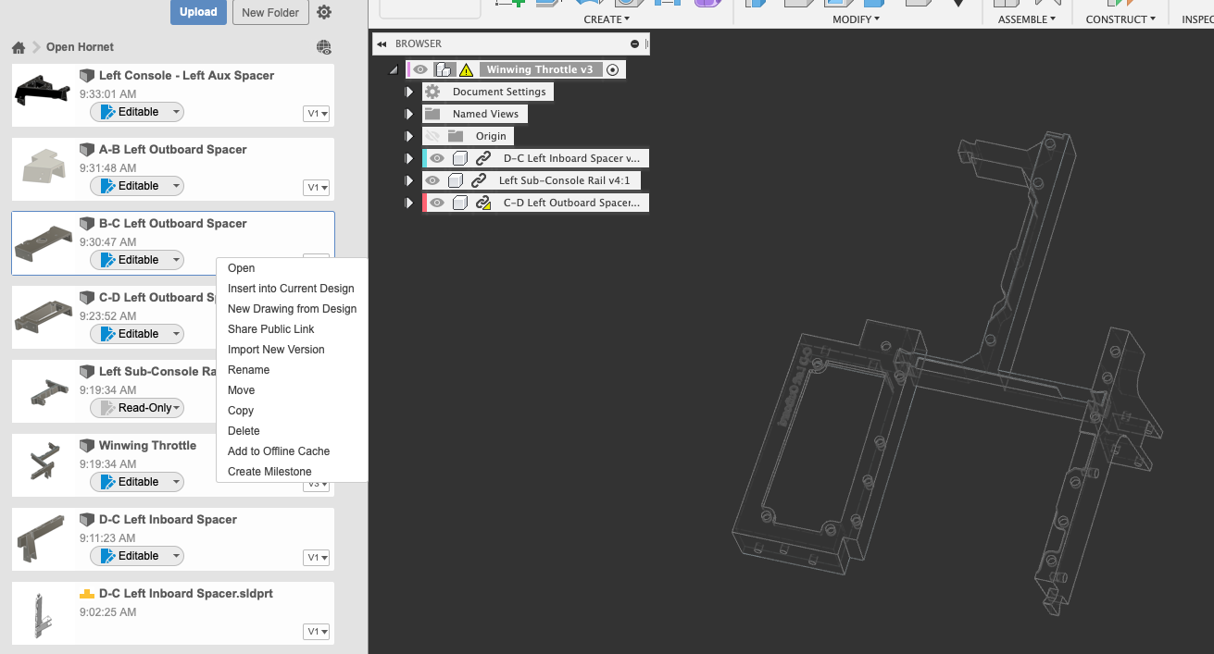

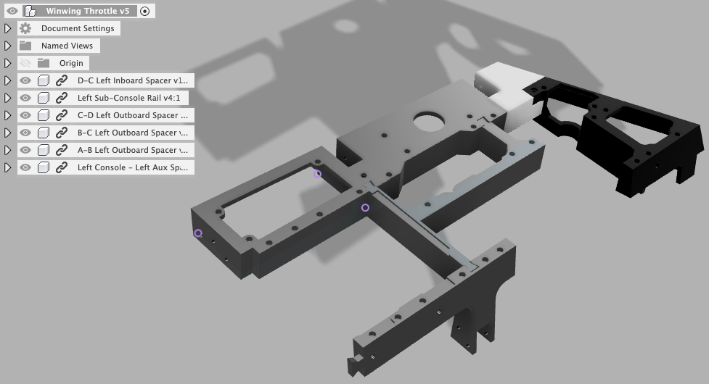

The rail is moved from 64.29mm to 74.37 = basically 10mm
Smaller hole is 11mm past outer hole 5.55mm
Notch is 19mm deep

Painting the DISP button

1/27/2021
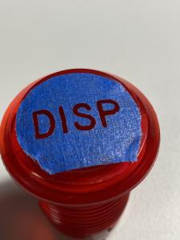
Saving for reference - three layers of blue masking tape

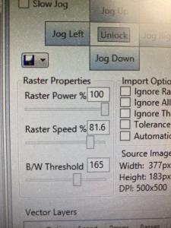

Do your best Ben

bnepethomas01/31/2021
how far away did you have the can from the surfect - 30cm? and how many coats

Ben-11101/31/2021
10-20 cm. 3 quick coats. Fast movement.

bnepethomas01/31/2021
ta and rough time between coats? 2min?

Ben-11101/31/2021
5 mins.

https://knowledge.autodesk.com/support/fusion-360/learn-explore/caas/sfdcarticles/sfdcarticles/How-to-Insert-a-Component-into-the-Current-Design-in-Fusion-360.html

